PROJECT DEFINITION AND DESIGN THINKING PHASE-1

Public Transport Optimization:

|  |  |
| --- | --- |
| DATE | 04/10/2023 |
| TEAM ID |  |
| PROJECT NAME | PUBLIC TRANSPORTATION AND OPTIMIZATION |

PROJECT DEFINITION:

* Introduction
* Definition of public transportation and optimization
* Integrating iot sensor
* Monitor ridership
* Track location
* efficiency
* Quality
* Iot using python

DESIGN THINKING:

A system of vehicles such as buses and trains that operate at regular times on fixed routes and are used by the public: Greater investment in public transportation would keep more cars off the roads.

TRANSPORTATION OPTIMIZATION is the process of analyzing shipments, rates and. constraints to produce realistic load plans that reduce overall freight spend and gain efficiencies across entire transportation networks.

INTEGRATING IOT SENSOR:

It's the process of connecting sensors and objects with one another and with your applications and databases. Once connected, you can implement end-to-end automations that help you make full use of your equipment.

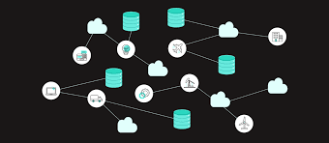

MONITOR RIDERSHIP IN PUBLIC TRANSPORTATION:

The online database is designed to capture all records of the bus passengers entering and leaving the bus. the result presents the GPS module able to get the exact location of the bus and detect its latitude and longitude. Passengers' activities on entering and leaving the bus are recorded every 5 seconds.

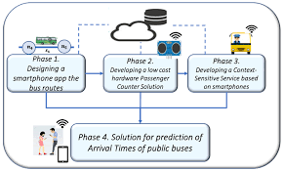

TRACKING LOCATION IN PUBLIC TRANSPORTATION:

the Internet of Things technology allows districts to easily track the location of their vehicles. Districts can install GPS systems on their vehicles that are connected to the internet. The GPS data is transmitted back to a central command center.

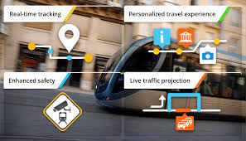

EFFICIENCY IN PUBLIC TRANSPORTATION:

This technology will further improve the passenger's experience on public transit by offering real-time vehicle tracking, notifications in case of an unexpected event, and personalized travel news to passengers.

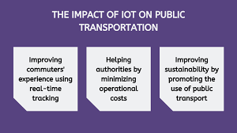

QUALITY OF PUBLIC TRANSPORTATION:

IoT provides real-time monitoring, which allows users to track their booked buses. With GPS tracking and real-time estimation, they can monitor the time it will take for the bus to reach the nearby station. Accordingly, they can reach the stop without waiting long hours.

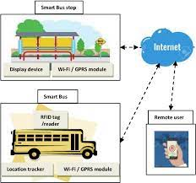

PYTHON USING IOT:

|  |
| --- |
|  |
|  | def transport_plan(data, dict_trucks, capacity_dict): |
|  | # List of Stores per Truck for each DAY |
|  | df_plan = pd.DataFrame(data.groupby(['Date', 'TruckID'])['Code'].apply(list)) |
|  | df_plan.columns = ['List_Code'] |
|  | # List of Box Quantity |
|  | df_plan['List_BOX'] = data.groupby(['Date', 'TruckID'])['BOX'].apply(list) |
|  | # Mean of FTL |
|  | df_plan['FTL'] = data.groupby(['Date', 'TruckID'])['FTL'].mean() |
|  | df_plan['Capacity(T)'] = df_plan['FTL'].map(capacity_dict) |
|  | df_plan['List_Loading'] = data.groupby(['Date', 'TruckID'])['Loading(T)'].apply(list) |
|  | df_plan['Count'] = df_plan['List_Loading'].apply(lambda t: len(t)) |
|  | df_plan['Total_tons(T)'] = data.groupby(['Date', 'TruckID'])['Loading(T)'].sum() |
|  |  |
|  | # Distribute: one shipment per col |
|  | # Stores |
|  | d = df_plan['List_Code'].apply(pd.Series) |
|  | for col in d: |
|  | df_plan["Store%d" % (col+1)] = d[col] |
|  | # Boxes number |
|  | d = df_plan['List_BOX'].apply(pd.Series) |
|  | for col in d: |
|  | df_plan["Box%d" % (col+1)] = d[col] |
|  | # Shipments Tonnage |
|  | d = df_plan['List_Loading'].apply(pd.Series) |
|  | for col in d: |
|  | df_plan["Tons%d" % (col+1)] = d[col] |
|  |  |
|  | # Fill NaN + Drop useless columns |
|  | df_plan.fillna(0, inplace = True) |
|  | if 1 == 0: |
|  | df_plan.drop(['List_Code'], axis = 1, inplace = True) |
|  | df_plan.drop(['List_BOX'], axis = 1, inplace = True) |
|  | df_plan.drop(['List_Loading'], axis = 1, inplace = True) |
|  |  |
|  | return df_plan |